M/S SYADD1 1st Term 2025-2026 Individual Weekly Status Report
Full Name: Fracie Princes G. Puyot Date: October 10, 2025 Section: MI232 Week #:10
Create a Word Document for this assignment and then export to PDF. Submit your PDF file.
Openproject Daily Scrum Reports for Sprint 1 Week 2 (Week 10)

Daily Scrum Report Day 01 (Link to Openproject Forum post)
Scrum Report Day 01
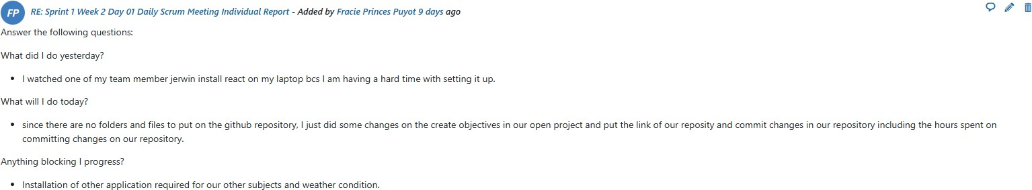

Daily Scrum Report Day 02 (Link to Openproject Forum post)
Scrum Report Day 02
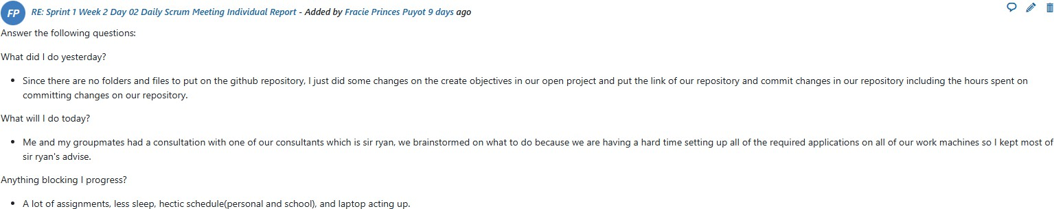

Daily Scrum Report Day 03 (Link to Openproject Forum post)
Scrum Report Day 03
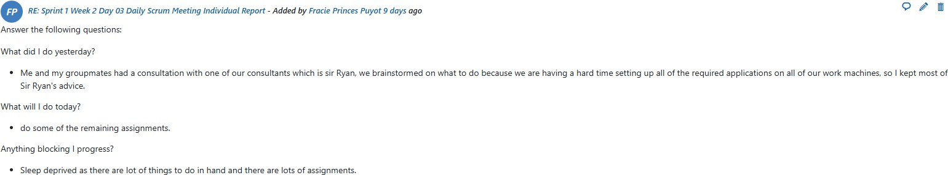
Daily Scrum Report Day 04 (Link to Openproject Forum post)

Scrum Report Day 04
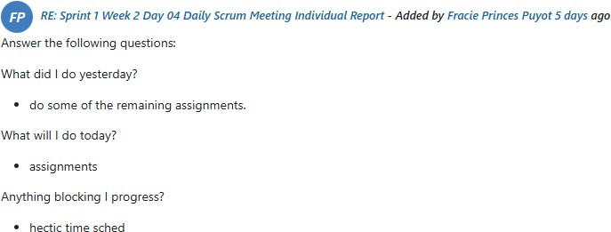
Daily Scrum Report Day 05 (Link to Openproject Forum post)
Scrum Report Day 05
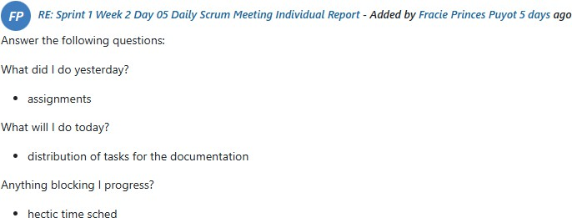

Daily Scrum Report Day 06 (Link to Openproject Forum post)
Scrum Report Day 06

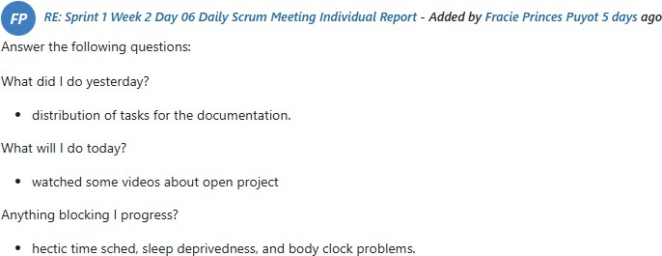
Daily Scrum Report Day 07 (Link to Openproject Forum post)
Scrum Report Day 07
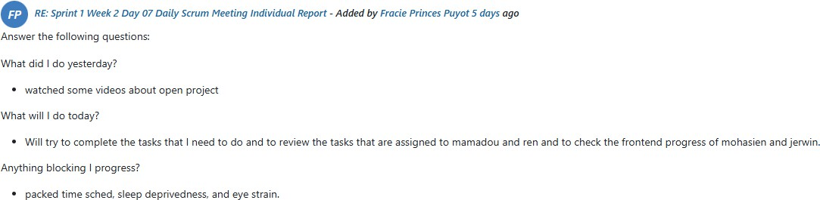

Openproject Assigned Work Packages Work Package – Executing Phase (Link)

